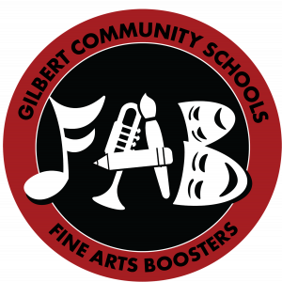
Gilbert High School
Fine Arts Boosters
2022 Award Application
Name:
Phone: E-Mail:

Gilbert Fine Arts Participation
Please specify details about your participation in each box that applies. For example, instrument/part/chair for band, specific role for plays/musicals, groups for large group speech, etc. Applicants need not have participated in all categories listed to be eligible for an award.
 | Freshman | Sophomore | Junior | Senior
Instrumental
concert band, jazz band, pep band, contest
Vocal
choir,
Tiger Voices,
contest

Drama
musicals,
plays,
variety show

Speech
individual,
group

Art
classes,
Art Club, yearbook, art shows
Other
dance team, writing, etc.

Essay Section
*Please note that while the writing quality of your essays is important, the content and your experiences are more meaningful in our consideration of your application.

- How has your involvement in the fine arts enhanced your life?
- What do you consider to be your top fine arts accomplishment while at Gilbert?
- Describe your community involvement in the fine arts, including ways that you may have used your talent to assist or enrich the lives of others
- How do you envision continuing your involvement in the fine arts in the next 5-10 years?

Application deadline is Friday, April 22nd.
Please limit completed form to two pages. Scholarships must be used for qualified education expenses, including tuition, fees, and course-related expenses.

E-mail completed application to info@gcsdfab.com.

